GamemasterScrawl: Technical Requirements Document (3) (Parker Hoffman)
Project Name: | GamemasterScrawl(5)
Date: | 4/20/2026
Prepared by: | Parker Hoffman
Document status (draft, proposed, validated or approved) | Approved

1. Introduction
This document contains the system requirements for GamemasterScrawl. These requirements have been derived from several sources, including Foundry Virtual Tabletop, Mozilla, Three.JS

1.1 Purpose of This Document
This document is intended to guide development of GamemasterScrawl. It will go through several stages during the course of the project:
- Draft: The first version, or draft version, is compiled after requirements have been discovered, recorded, classified, and prioritized.
- Proposed: The draft document is then proposed as a potential requirements specification for the project. The proposed document should be reviewed by several parties, who may comment on any requirements and any priorities, either to agree, to disagree, or to identify missing requirements. Readers include end-users, developers, project managers, and any other stakeholders. The document may be amended and re-proposed several times before moving to the next stage.
- Validated: Once the various stakeholders have agreed to the requirements in the document, it is considered validated.
- Approved: The validated document is accepted by representatives of each party of stakeholders as an appropriate statement of requirements for the project. The developers then use the requirements document as a guide to implementation and to check the progress of the project as it develops.

1.2 How to Use This Document
We expect that this document will be used by people with different skill sets. This section explains which parts of this document should be reviewed by various types of readers.

Types of Reader
- GameMaster (DMs)
- Only Section 2 is necessary to read
- Players
- Only Section 2 is necessary to Read
- Future Developers/Content Creators
- Sections 2 And 3 Are most useful
- Project Overseers
- The entire document is useful

Technical Background Required
Section 2 is intended for a less technically savvy audience, which will include the general user, Players, or gamemasters.
Sections 3 and 4 are intended for more of a developer view, as technical CS terms or other project-specific language will be used

Overview Sections
Sections 1.3, 1.4, and 1.5 are very useful for a general overview of the product

Reader-Specific Sections
There are currently no sections designated for only the eyes of one group, but section 3 is more technical and is discouraged for those not interested in understanding the product at a deeper technical level

Section Order Dependencies
Currently, reading sections 1.3-1.5 will be a good place to start reading this product. 2.0 and 2.1 should logically follow. Section 3 is one of the last reads a user should do.

1.3 Scope of the Product
The scope of this project is to allow one superuser and multiple normal users to interact with a 3D space and manipulate various characters, or tokens, freely around this space. This space should be editable by the superuser, and they should also control which tokens the normal users can move around the space. As users request updates, changes should be visible to all users.

1.4 Business Case for the Product
In my experience playing TTRPGs like Dungeons and Dragons, combat is a vital role. In combat, positioning of both allies, enemies, and terrain is vital in making every combat encounter feel unique and developing strategies. One program that helped with this is called Foundry VTT. However, Foundry is not without its flaws. Foundry is designed to work on a 2D plane only. While there are times when this is sufficient, it demonstrates deep flaws whenever either the enemies or the players start to think in three dimensions, whether this be from flight, or burrowing into the terrain. This can lead to confusion, as the map doesn’t clearly mark these statuses.To make this complicated, according to the DND 2024 wikidot, 20% of the base ‘species’ a player can be have the ability to fly. Thus, players will always have the option to fly, without items, spells, or other abilities. Thus, it is imperative to create a solution to reduce confusion at the table and streamline the TTRPG experience.
1.5 Overview of the Requirements Document
- All normal clients are browser-based
- This supports multiple normal users at once
- All users can change perspective on the 3D space
- All users can move tokens in 3D space
- The Superuser (Or gamemaster) can control who can move certain tokens
- The gamemaster can create/edit maps

2. General Description
This section will give the reader an overview of the project, including why it was conceived, what it will do when complete, and the types of people we expect will use it. We also list constraints that were faced during development and assumptions we made about how we would proceed.

2.1 Product Perspective
Hi! I’m Parker Hoffman, and I’m a Computer Science student who enjoys playing TTRPGs like Dungeons and Dragons. After playing D&D and using Foundry VTT, a map management software for D&D, I came into contact with one of its weaknesses. Since Foundry is designed on a 2D plane exclusively, it makes it difficult to imagine or quickly tell things about the depth involved in a scenario. The height of a room must be asked on entry (or necessity of the information) of a new room, which leads to repetitive questioning from some of the players to the GameMaster. In addition, the GameMaster already has a large amount of information they must constantly balance. Balancing the actual height/depth of a player/enemy can be difficult, and makes calculating projectile distance, range, or if the player/enemy is in the AoE of an action difficult. This can lead to some arguing over the table that could be easily avoided. As such, this product aims to fix this by providing a map management software with a 3-Dimensional approach from the start. As such, it will benefit both Players and the GameMasters by reducing confusion and streamlining the experience of playing a TTRPG together.

2.2 Product Functions
This product is designed to be the map for a TTRPG system. As such, it should be able to run in tandem during a session. In addition, it should be able to do the following:
- Create/Edit Maps
- Add Interactable Features to Maps
- Create/Edit Tokens
- Upload Images for Tokens
- Move Token in 3D space
- View/change perspective in 3D space
- Basic User Management

2.3 User Characteristics
The main group of people using this app are people with an interest in playing a TTRPG. These users typically desire a system that just works without any extra thought on their part. In addition, these users typically start with some basic computer system understanding. As such, they are expected to have very little technical training to use this application. Thus, it means that it is imperative to design an easy-to-pick up and intuitive system. The most complex thing anyone should be doing with my program is designing a map. Thus, it needs to be intuitive on how to design the map, build it, and place features. This is the largest obstacle for a user to overcome.
The only thing the users will need to be an expert in is how to play the TTRPG system they desire, which is outside of my program’s scope.

2.4 General Constraints
- This program will rely on existing web-browser technology for Players to connect and interact with the system.
- This program will rely on existing internet protocols, including Sockets, to transfer information.
- The Player’s client will be totally Browser-based, including the 3D environment. This also means it must be mobile responsive and fairly lightweight to support running on any browser.
- The main tech stack is a C#-based console app that relies on existing .NET frameworks to help handle the system.

2.5 Assumptions and Dependencies
For distribution purposes, it is assumed there is an intuitive website that offers a downloadable .exe file for the Gamemaster to run on their compatible device.
It is assumed the GameMaster will have a relatively recent computer with Windows Operating System installed and running on the device to host this program.
It is assumed that every user (GameMaster or Player) will have a consistent access to reliable internet throughout the entire period of use.
It is assumed that every end user will have a unique device with an up-to-date browser.

3. Specific Requirements
This section of the document lists specific requirements for GamemasterScrawl. Requirements are divided into the following sections:
- User requirements. These are requirements written from the point of view of end users, usually expressed in narrative form.
- System requirements. These are detailed specifications describing the functions the system must be capable of doing.
- Interface requirements. These are requirements about the user interface, which may be expressed as a list, as a narrative, or as images of screen mock-ups.

3.1 User Requirements
This system needs to be able to handle multiple users interacting and requestion changes on the data at once. It needs to visually display the data in an intuitive 3-dimensional view for ease of understanding. It needs to have intuitive ways to move the data

3.2 System Requirements

- Real-Time multi-user Token Management
- Internal Map Creation and Editing
- Token Permission per user
- 3D camera movement within a web browser environment
- Maintain a private data store for use and persistence after closing the application

3.3 Interface Requirements
First, the login screen:
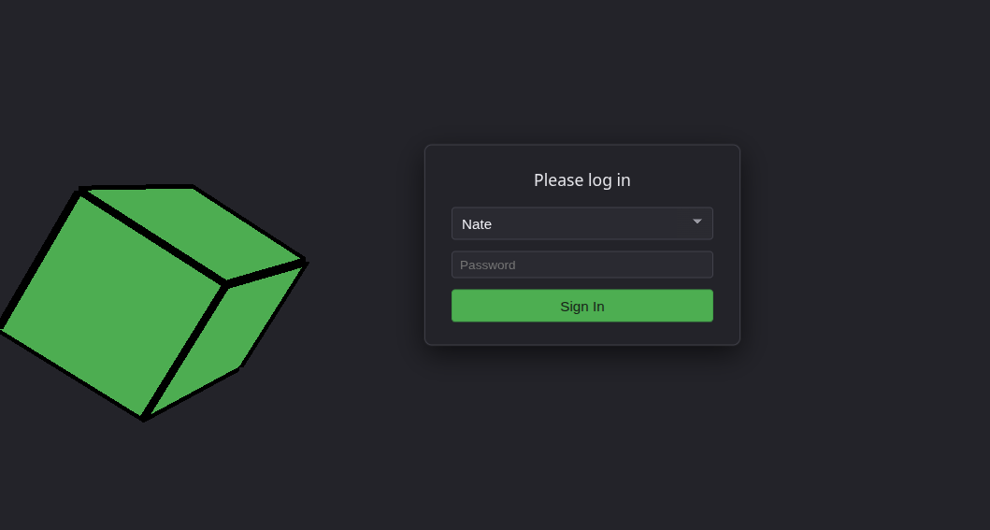
Then, the first Homepage Mockup:
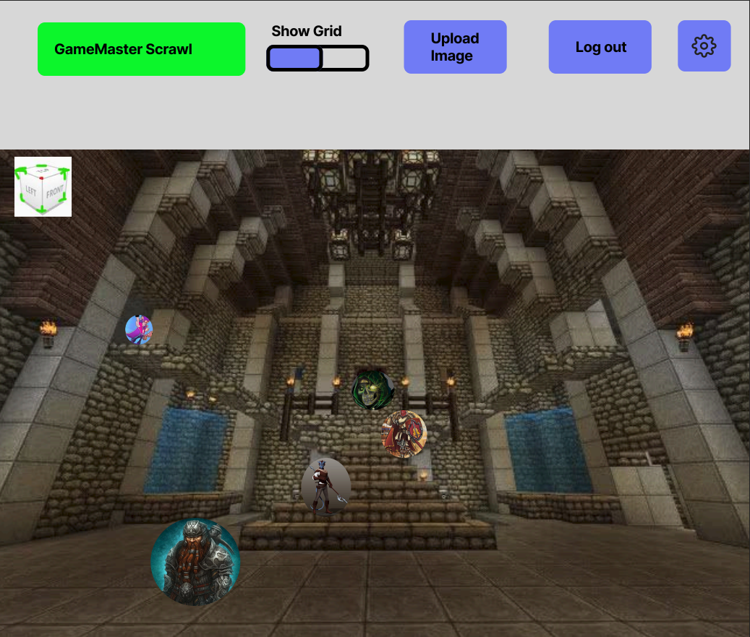
Above is the main interface screen for a player. The main hub at the top includes a way to show the grid, and the interactable spaces on the map. In the image, it is switched to the ‘off’ state.
- Next to that is the ability for a user to upload an image to be assigned to a token.
- Next to that, the user can sign out of this account
- Beneath the upper bar is the main map space. The user can rotate their camera by interacting with the cube in the upper-left part of the map. By moving their mouse around that, they can rotate the camera (and their perspective) around the current space
- To move a token, it should just be drag-and-drop

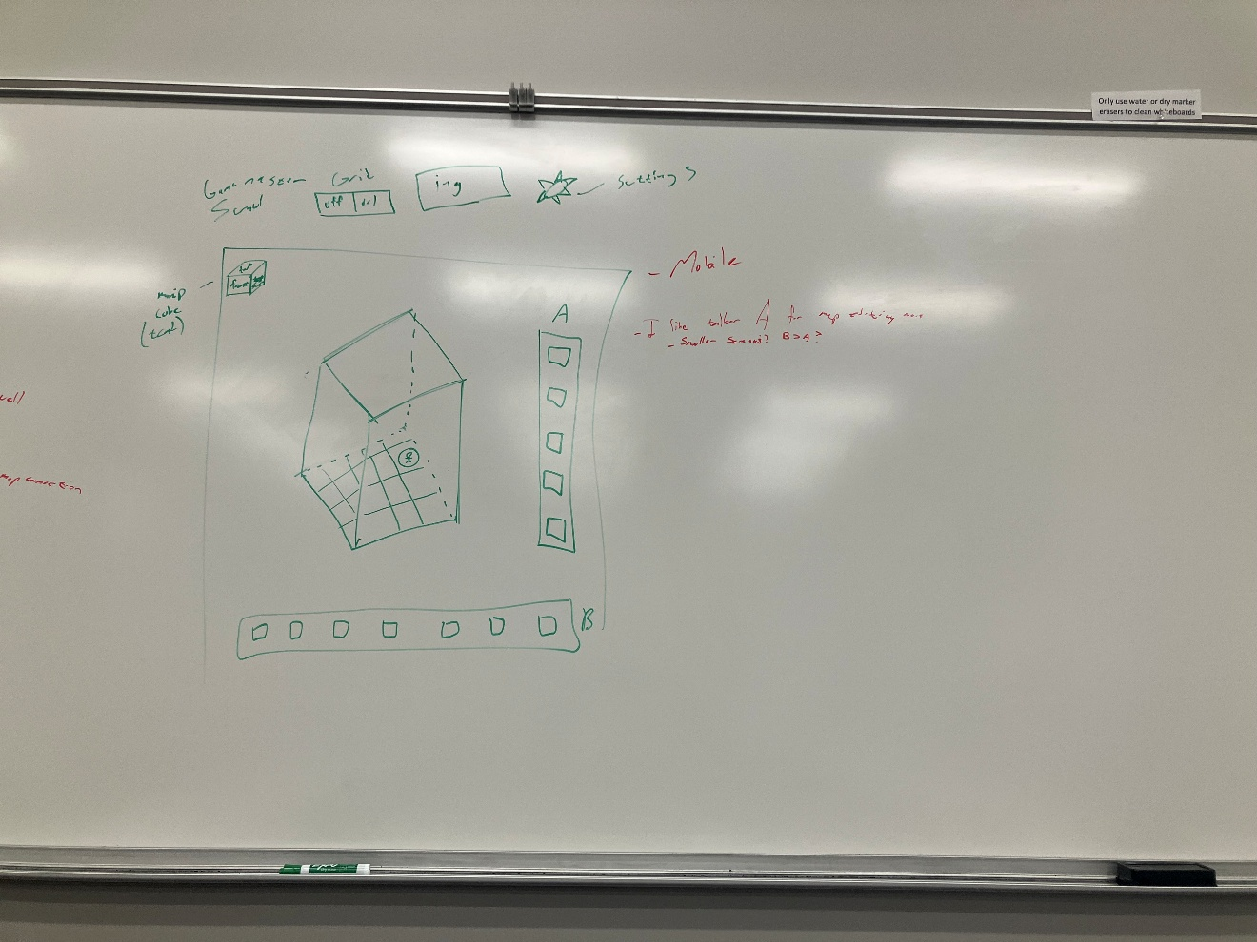Above is an early draft of the UI, with sidebars to visualize

The addition screen has evolved to the following:

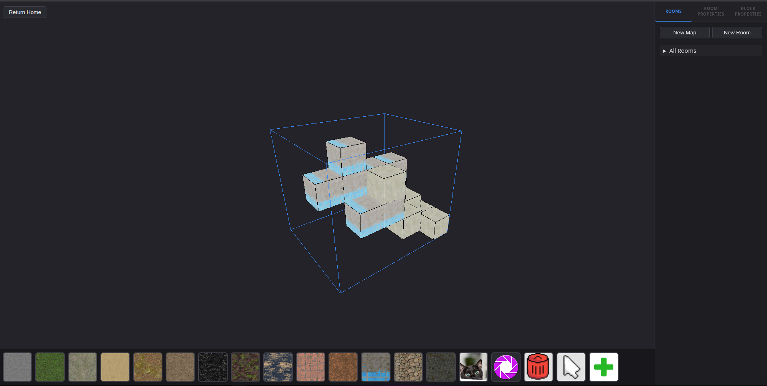
The above concept also is used on the home screen. Here is the main screenshot before some heavy styling:

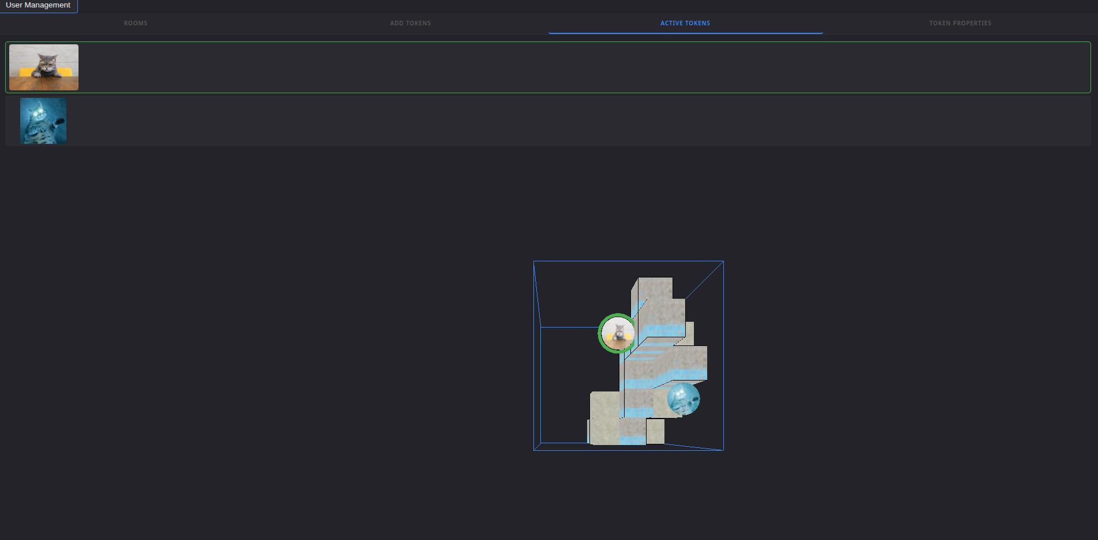

Next, there is a basic user management screen. This will populate with users as they are created, and will allow the host to edit passwords and do some basic user management

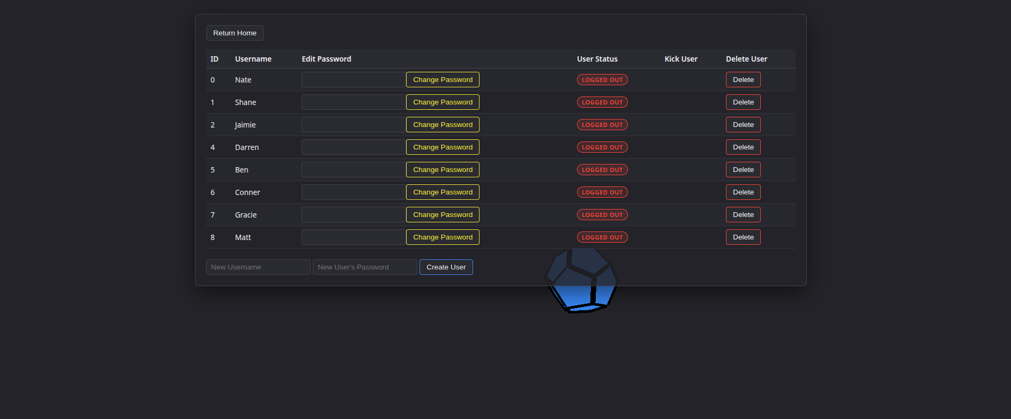

There is also a basic token editing screen. It follows a similar principle. Below are the adding image function and the creating a token functionality
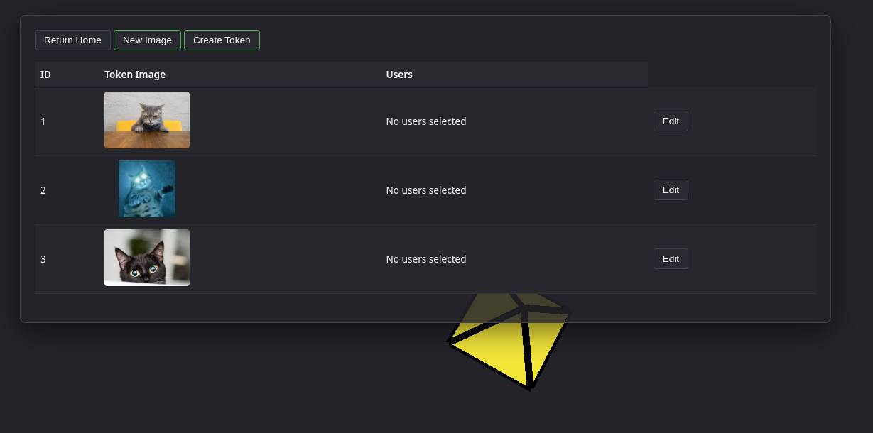
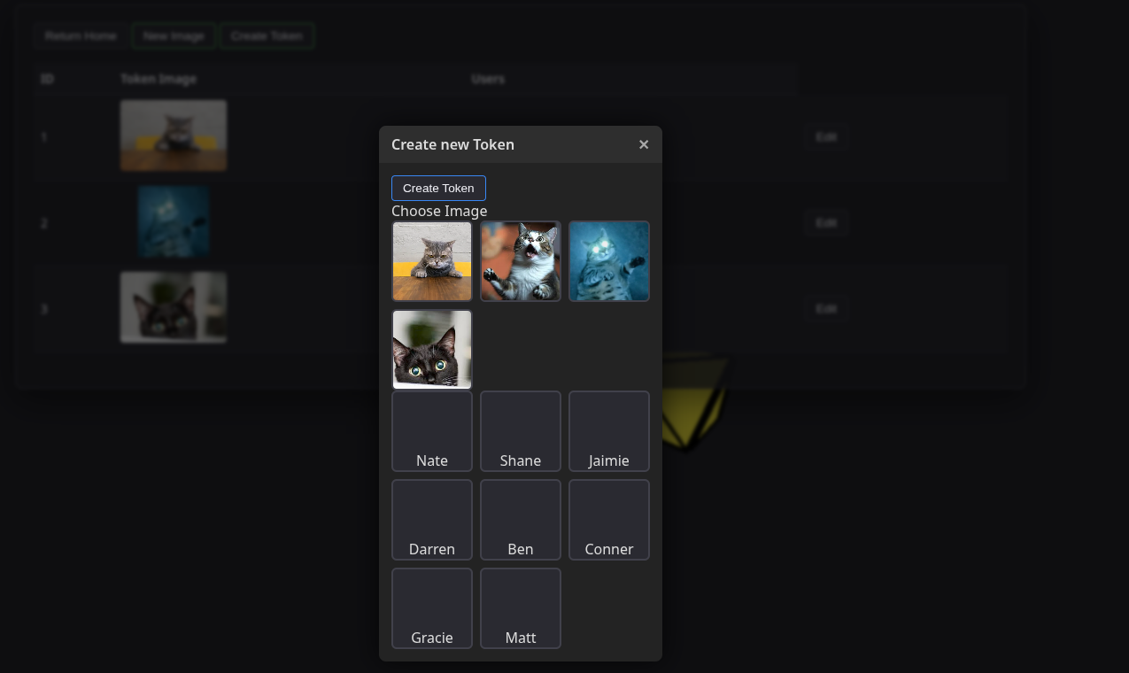

4. Appendices
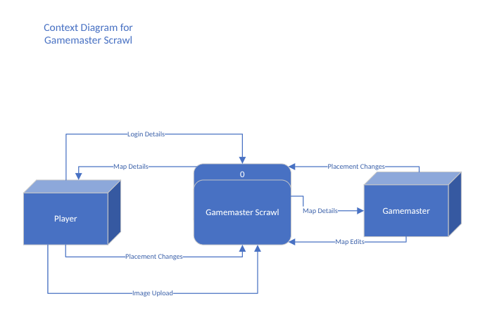
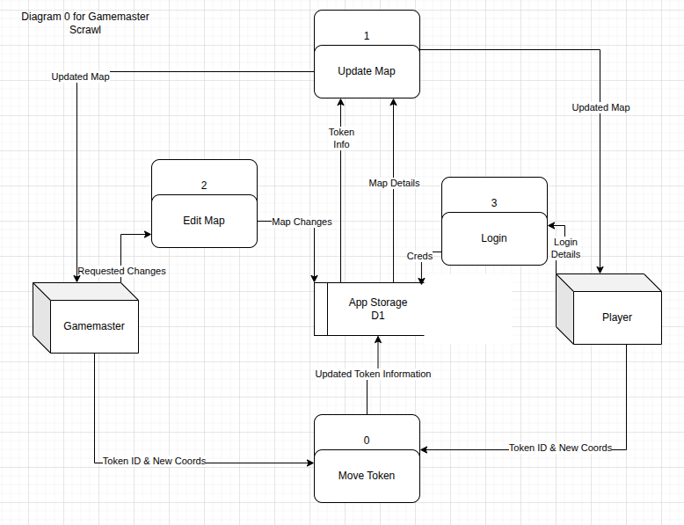
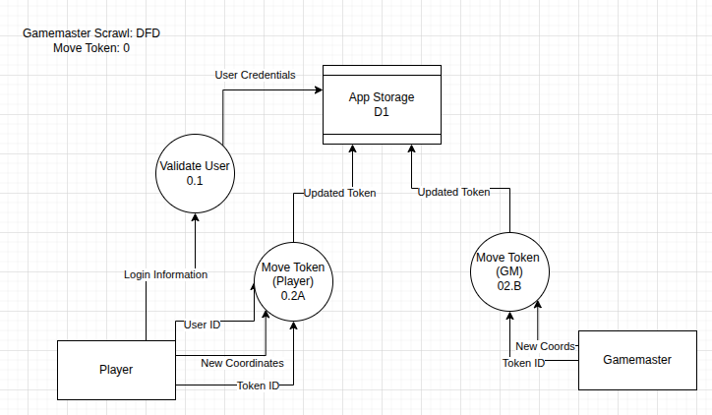

Functional Decomposition Diagram:
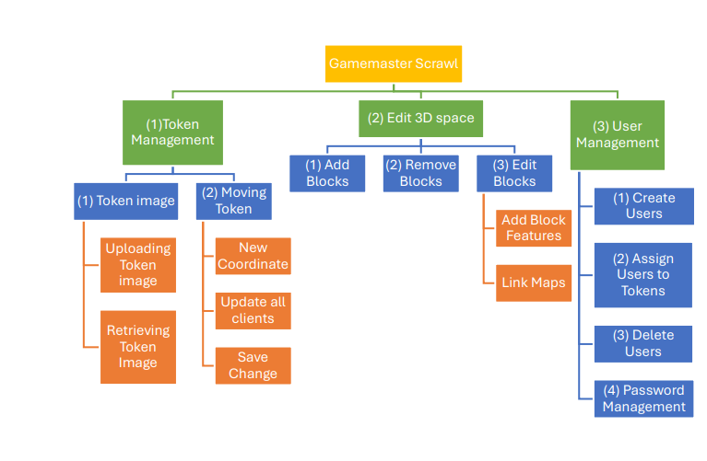

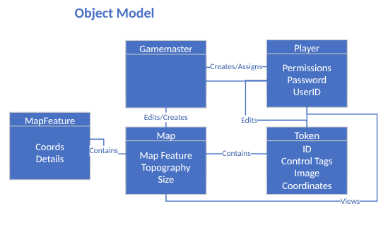


Below is a list of Logo Drafts
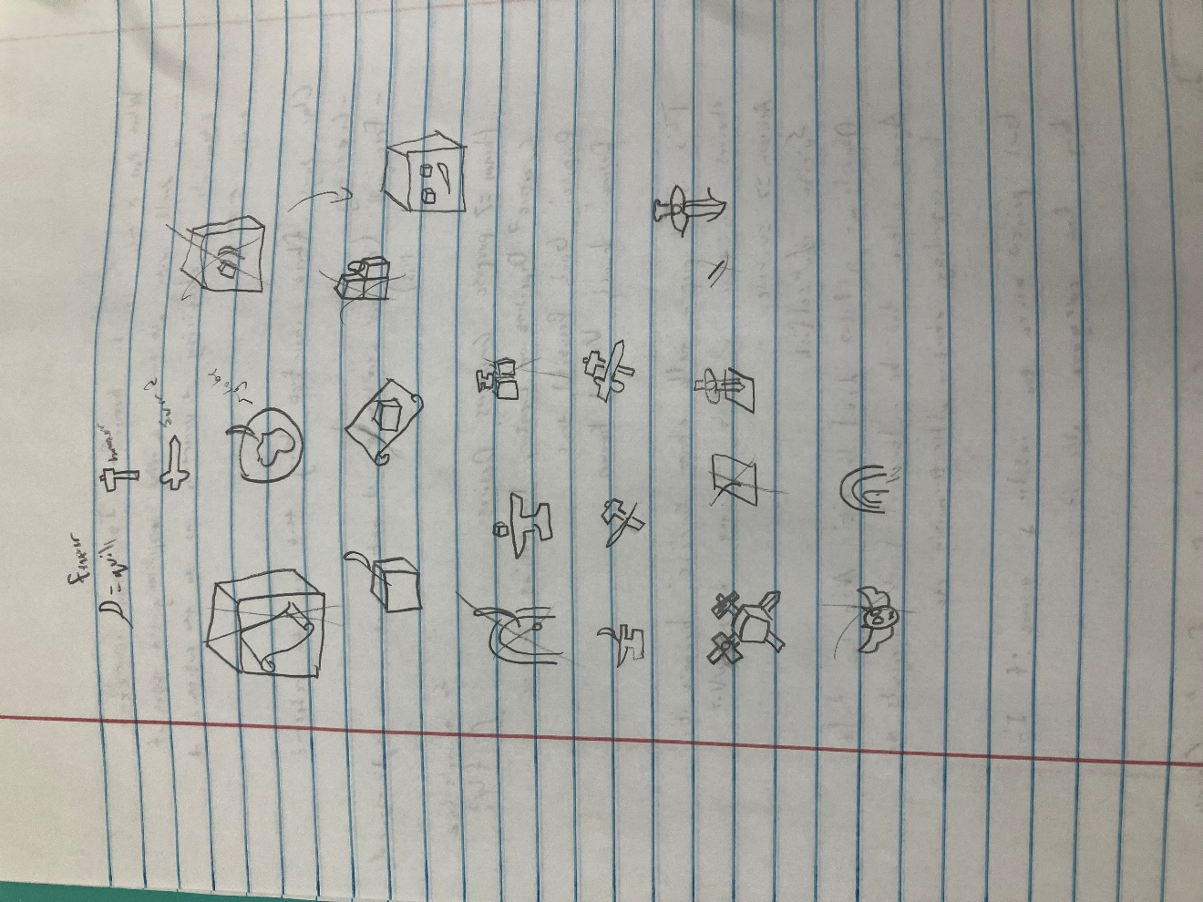
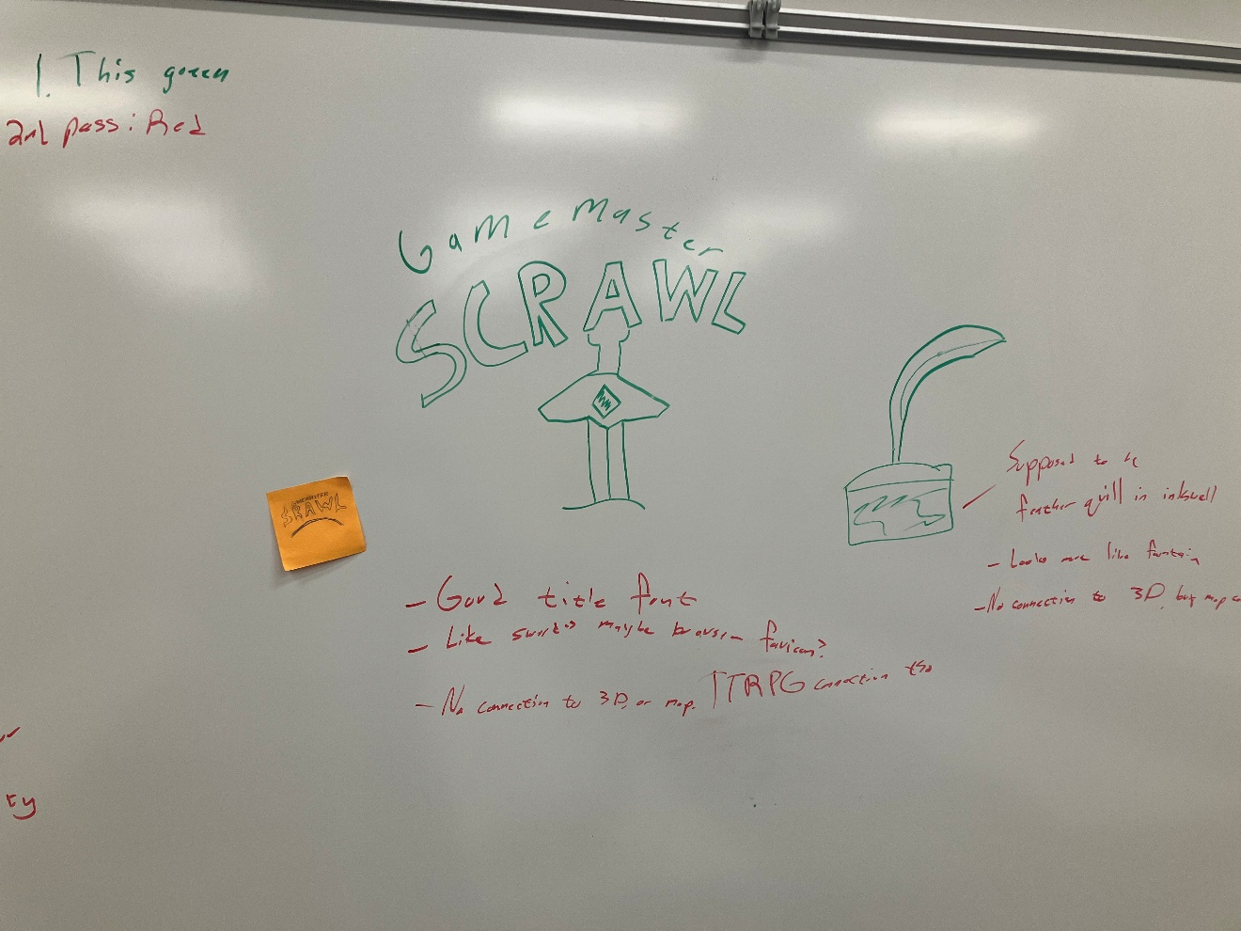
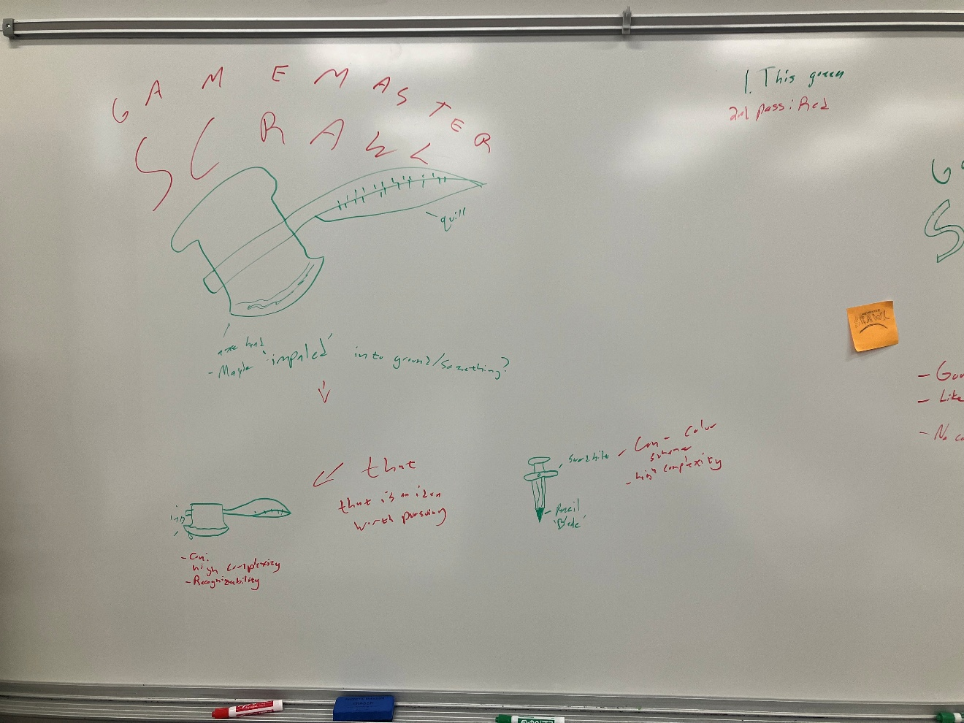
Below is the actual Logo:

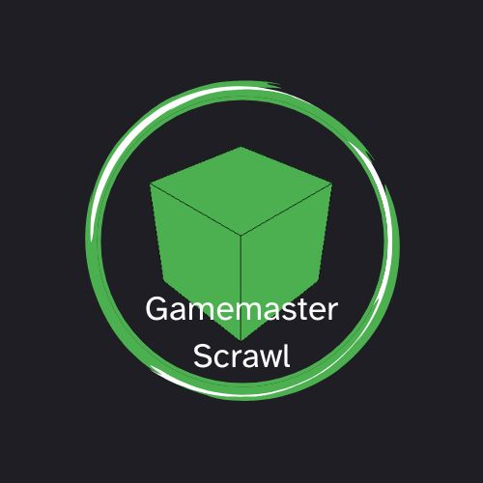
And the Favicon:

- Wish-listed Features:
  - Map Import Utility
  - Assigning sub-Superusers
  - Measurement Tools (AoE bubbles, Distances)
  - Animations
  - Custom Model support
  - 2D plane View(s)
  - Dice rolling utility
  - Turn Order Manager
  - Built-In Stat-block manager
  - Physics System
  - Interactable Blocks

5. Glossary
TTRPG: This stands for Table-Top Roleplaying Game. This is when a group of people get together and play a structured version of make-believe over a set period of time. Different people at the table have different roles, like player or Gamemaster. The structure comes from a rule set they agree to play with. These rule sets would typically be referred to by names like Dungeons and Dragons, Pathfinder, Lancer, etc.
Gamemaster: The super user running the TTRPG session. This person has planned the entire adventure and is the main storyteller of the session. Sometimes referred to as ‘Dungeon Master’ or other terms, depending on the context
Player: This is any other person interacting with the story. These people make decisions that greatly influence the story
AoE: This stands for Area of Effect. This is the space a action takes up. Think if a loud sound were to play, its area of effect would be everywhere it can be heard. These typically take a spherelike appearance around the terrain. This is typically used in things like explosions.
Socket: This is when a client maintains a connection with a host (typically a server) over the internet, instead of terminating the connection after it receives the information it wants
Client: User interacting with the program. This will typically denote someone with no special permissions or access to features
Superuser: This is a user with higher access to various parts or features of the application
Map: This is the 3D space in which Tokens, or other actors are being manipulated within
Block: This is one grid space of the map. This can have interactable properties, be empty, or have the space filled
Token: This is a little circle (possibly with an image) representing an actor in the space. It could represent a player’s character, an enemy, an ally, or any other moveable creature in the space. This is what is moved around in the space

6. References
BabylonJS. (n.d.). BabylonJS/babylon.js: . GitHub. https://github.com/BabylonJS/Babylon.js
Foundry Virtual Tabletop. (n.d.). https://foundryvtt.com/
IBM. (2007, October 25). IBM Socket Documentation. How sockets work. https://www.ibm.com/docs/en/i/7.4.0?topic=programming-how-sockets-work
MozDevNet. (n.d.). Game development. MDN Blog RSS. https://developer.mozilla.org/en-US/docs/Games/Techniques/3D_on_the_web
Owlbear rodeo. Owlbear Rodeo. (n.d.). https://www.owlbear.rodeo/
D&D 5e (2024). (n.d.). Home - D&D 5e (2024). http://dnd2024.wikidot.com/. Accessed 2 February 2026
Three.js – JavaScript 3D library. (n.d.). https://threejs.org/

